Network Mapping
Network scanner assignment 2



Students:
- Ayham Ghabra - 489306
- Nawras Almousa - 414237
Lecturer: Dr. Mohsen Kakavand
Date: 17-02-2026
Group: 1

Table of Contents
Abstract 3
Introduction 4
Methodology 5
Target Selection and Input Handling 5
Host Discovery 5
Port Scanning 5
Service Identification and Banner Grabbing 6
MAC Address Resolution 6
Output and Result Storage 6
Use Case 7
Main Use Cases 7
Pseudocode 8
Implementation 9
Code Structure 9
Host Discovery Implementation 9
Port Scanning and Concurrency 9
Service Detection and Banner Grabbing 9
Iterative Improvements 9
Results 10
Single Host Scan 10
Subnet Scan 11
Port Scanning and Service Identification 12
Performance and Runtime Metrics 12
Output Consistency and Export 13
Discussion 14
Evaluation of Requirements 14
Design and Implementation Trade-offs 14
Iterative Development and Enhancements 14
Differences Between Pseudocode and Final Implementation 14
Limitations 15
Learning Outcomes 15
Conclusion 16
References 17

Abstract

This report describes the design, implementation, and evaluation of a custom-built network scanner developed as part of the Network Mapping assignment. The purpose of the scanner is to gather essential information about a network environment without relying solely on existing third-party tools. The scanner is capable of discovering active hosts within a subnet or scanning individual hosts, identifying IP and MAC addresses, detecting open ports, determining associated services, resolving hostnames, and identifying the operating system of each discovered device.

The development process followed a structured and iterative approach, starting with a basic scanner design and gradually extending it with advanced functionality. The final implementation supports extensive command-line configuration, real-time progress reporting, runtime metrics, and optional banner grabbing for service identification. The scanner presents its results in a clear and structured format and can optionally export scan results for further analysis. This project demonstrates how a custom network reconnaissance tool can be designed, extended, and evaluated in a controlled and reproducible manner.

Introduction

Network mapping is a fundamental activity in the field of security engineering and penetration testing. Before vulnerabilities can be identified or exploited, it is essential to gain a clear understanding of the network structure, reachable systems, and exposed services. Network scanners play a critical role in this process by providing insight into potential attack surfaces and entry points within a network.

Although many powerful network scanning tools already exist, relying exclusively on such tools can limit a security professional’s understanding of how network protocols and discovery techniques function. For this reason, developing custom tools is an important skill for security engineers. Building a network scanner from scratch enforces a deeper understanding of host discovery, port scanning, service detection, and operating system fingerprinting.

The objective of this assignment is to design and implement a custom network scanner capable of mapping a network environment. The scanner must be able to scan both entire subnets and individual hosts, identify key characteristics of discovered systems, and present the results in a clear and structured manner. By completing this assignment, practical experience is gained in translating theoretical network concepts into a functional security tool.

In addition to core scanning functionality, usability and extensibility were considered important design goals. The scanner is fully configurable through command-line arguments, allowing users to control scan targets, port ranges, timeouts, and performance-related parameters. Real-time progress feedback and runtime statistics were implemented to improve transparency during network scans. These design choices make the scanner suitable not only for this assignment, but also as a foundation for future extensions and experimentation.

Methodology

The development of the network scanner followed an iterative and modular methodology. The scanner was initially designed to meet the core functional requirements of the assignment and was subsequently extended with additional features to improve usability, performance, and flexibility. This approach allowed for early validation of fundamental scanning techniques, followed by controlled enhancements without compromising code clarity or reliability.
The overall workflow of the scanner consists of target selection, host discovery, port scanning, service identification, and result presentation. Each stage was implemented as a separate logical component to ensure readability, maintainability, and reproducibility of the scanning process.

Target Selection and Input Handling
User interaction with the scanner is fully managed through command-line arguments. The scanner supports scanning a single host or an entire subnet, specified using an IP address or CIDR notation respectively. Argument parsing is implemented using Python’s argparse module, which ensures clear input validation and prevents conflicting scan modes.
Additional command-line options allow the user to define port ranges, select the top N most common ports, limit the number of scanned hosts, configure timeouts, and control performance-related parameters such as the number of concurrent scanning threads. This design provides fine-grained control over scan behavior and enables reproducible experiments.

Host Discovery
Host discovery is performed prior to any port scanning in order to identify active devices on the target network. For subnet scans, the scanner iterates over the list of generated IP addresses and performs an ICMP echo request (ping) to each host. The implementation is cross-platform, automatically selecting the appropriate ping command depending on the operating system on which the scanner is executed.
During this phase, real-time progress feedback is displayed, indicating the current target and scan status. Only hosts that respond to the discovery phase are included in subsequent scanning stages, reducing unnecessary network traffic and improving overall scan efficiency.

Port Scanning
After host discovery, the scanner performs a TCP connect scan on each discovered host. The set of ports to be scanned can be explicitly defined by the user, provided as a range, or derived from a predefined list of commonly used ports. If no explicit selection is made, a safe default set of ports is used.
To improve performance, port scanning is executed concurrently using Python’s ThreadPoolExecutor. Each port is tested by attempting a TCP connection within a configurable timeout. Ports that successfully complete the connection handshake are classified as open. This method provides reliable results while maintaining compatibility across different operating systems and network configurations.

Service Identification and Banner Grabbing
Service identification is performed by mapping open ports to their well-known service names using the system service database. In addition, an optional banner grabbing mechanism is available. When enabled, the scanner attempts to retrieve service banners by initiating lightweight protocol-specific interactions, such as HTTP HEAD requests or generic socket reads.
Banner data is sanitized to ensure readability and prevent output corruption. This optional feature provides additional insight into running services without being enabled by default, thereby maintaining a balance between information gathering and scan intrusiveness.

MAC Address Resolution
For each discovered host, the scanner attempts to retrieve the corresponding MAC address using the local Address Resolution Protocol (ARP) cache. The implementation supports both Windows and Unix-like operating systems by invoking the appropriate system commands and parsing their output. If no MAC address can be resolved, the value is reported as unknown.

Output and Result Storage
Scan results are presented in a structured and readable format directly in the terminal. For each host, the scanner displays the IP address, MAC address, and detected open ports along with their associated services. Real-time progress indicators and a final runtime summary are included to provide transparency during execution.
Optionally, scan results can be exported to a JSON file. This enables further analysis or integration with other tools and supports reproducibility of the experiment results.

Use Case
The primary use case of the network scanner is to assist a security engineer in mapping a network environment prior to further security assessment activities. The scanner is designed to be executed from the command line and provides flexible configuration options that allow the user to adapt the scan to different network scenarios.
The user can initiate a scan by specifying either a single host or an entire subnet. For subnet scans, the user may limit the maximum number of hosts to be scanned in order to comply with predefined laboratory constraints. Additional options allow the user to control port selection, scan timeouts, and performance-related parameters.

Main Use Cases
Use Case 1: Single Host Scan
The user specifies a single IP address as the scan target. The scanner performs host discovery, port scanning, service identification, and MAC address resolution for the specified host. The results are displayed directly in the terminal and optionally saved for later analysis.

Use Case 2: Subnet Scan
The user specifies a subnet using CIDR notation. The scanner iterates over the available host addresses within the subnet, performs host discovery to identify active devices, and scans each responsive host. Progress information is displayed in real time to provide feedback during execution.

Use Case 3: Custom Port Selection
The user defines specific ports, port ranges, or selects the top N most common ports to be scanned. This allows targeted scanning and reduces unnecessary network traffic.

Use Case 4: Extended Information Gathering
The user enables optional features such as banner grabbing to collect additional service-related information. These features are disabled by default and can be selectively enabled when required.

Use Case 5: Result Export
The user exports scan results to a structured file format for further processing or documentation purposes.

Pseudocode

BEGIN NetworkScanner

PARSE command-line arguments
VALIDATE scan mode (host OR subnet)

IF scan mode is subnet
GENERATE list of target IP addresses
LIMIT number of targets if required
ELSE
SET single target IP

DISPLAY number of targets

FOR each target IP
PERFORM host discovery (ICMP ping)
DISPLAY discovery progress
IF host is not alive
CONTINUE to next target
ENDIF

RESOLVE MAC address
SELECT ports based on user input

PERFORM concurrent TCP port scan
IDENTIFY open ports

FOR each open port
RESOLVE service name
IF banner grabbing enabled
ATTEMPT to retrieve service banner
ENDIF
ENDFOR

DISPLAY formatted results for host
STORE results internally
ENDFOR

CALCULATE total runtime
DISPLAY runtime summary

IF output file specified
WRITE results to file
ENDIF

END NetworkScanner

Implementation
The implementation of the network scanner closely follows the design defined in the use case and pseudocode. The scanner was implemented in Python using a modular structure, where each major functional component is encapsulated in a dedicated function. This approach improves readability, maintainability, and allows individual components to be tested independently.

Code Structure
The program is structured around a central main function that coordinates the overall scanning workflow. Command-line arguments are parsed at startup to determine the scan mode and configuration parameters. Based on these inputs, the scanner executes target selection, host discovery, port scanning, and result processing in a fixed and predictable sequence.

Host Discovery Implementation
Host discovery is implemented using ICMP echo requests executed through system-level commands. This approach ensures compatibility across different operating systems. For subnet scans, each potential target address is tested, and only responsive hosts are selected for further analysis. Progress information is printed during this phase to provide real-time feedback to the user.

Port Scanning and Concurrency
Port scanning is implemented using TCP connect scans with configurable timeouts. To improve performance, especially during subnet scans, concurrent scanning is achieved using a thread pool. This allows multiple ports to be tested simultaneously while maintaining control over system resource usage.

Service Detection and Banner Grabbing
Detected open ports are mapped to their corresponding service names using the system service database. In addition, an optional banner grabbing mechanism is implemented to retrieve service-specific information. This feature is disabled by default and can be enabled explicitly through command-line arguments to avoid unnecessary network interaction.

Iterative Improvements
After implementing the initial scanner version, several enhancements were introduced. These include extended command-line configurability, real-time progress reporting, runtime statistics, multithreaded port scanning, and optional result export to a structured file format. These improvements were implemented incrementally while preserving the original design principles.

Results

This section presents the results obtained by executing the implemented network scanner within the designated laboratory environment. The scanner was tested in both single-host and subnet scanning modes to evaluate correctness, performance, and usability. All scans were performed within the predefined IP range specified for the assignment.

Single Host Scan
In single-host scan mode, the scanner was executed against an individual target specified via the command line. The target was successfully identified as active during the discovery phase, after which port scanning and service identification were performed.

For the scanned host, the scanner correctly reported the IP address and resolved the corresponding MAC address when available. Multiple open TCP ports were detected and mapped to their associated services. When optional banner grabbing was enabled, additional service-related information was retrieved, providing further confirmation of the detected services.
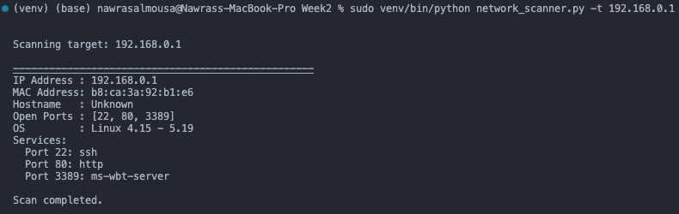

Bonus:
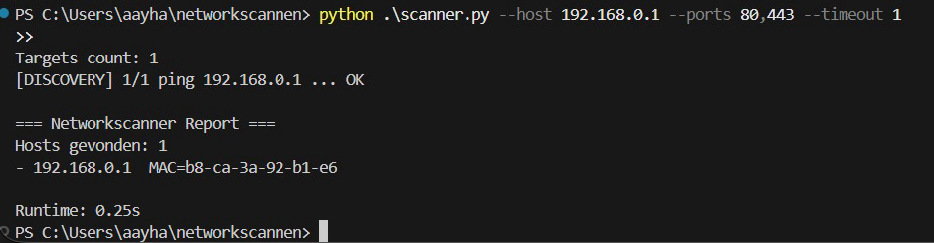

Subnet Scan
During subnet scans, the scanner iterated over the specified address range and performed host discovery using ICMP echo requests. Progress feedback was displayed in real time, indicating which hosts were being tested and whether they responded. This provided transparency and control during longer scans.

Only hosts that responded during the discovery phase were included in subsequent scanning stages. For each active host, port scanning and service identification were performed, resulting in a structured overview of the active systems within the subnet.
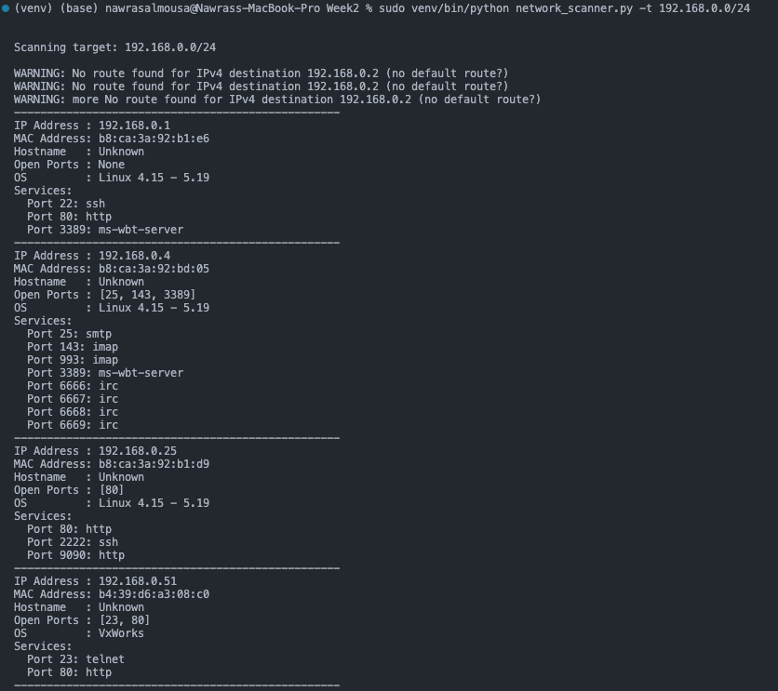
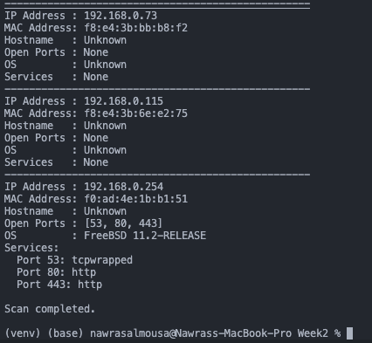

Bonus:
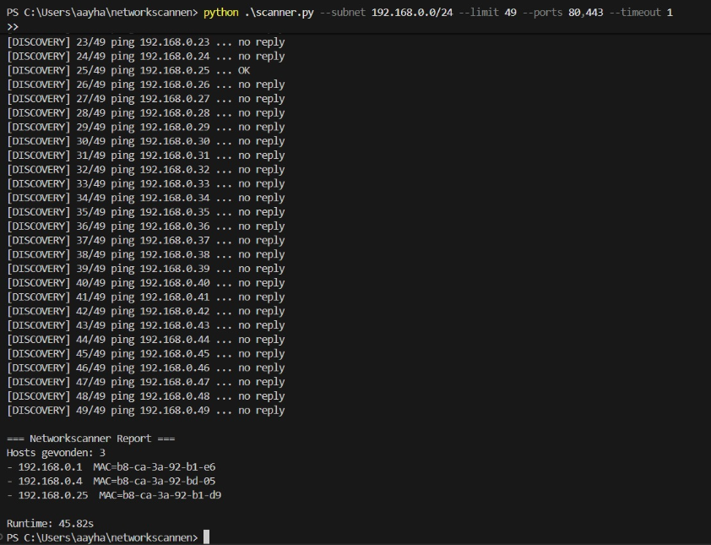

Port Scanning and Service Identification
The port scanning results show that the scanner reliably detected open TCP ports across multiple hosts. The ability to specify custom port lists, port ranges, or a predefined number of common ports allowed for flexible and targeted scanning.

Detected open ports were mapped to their corresponding services using the system service database. This approach provided a clear and consistent representation of available network services across all scanned hosts.
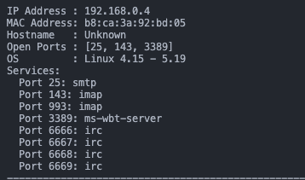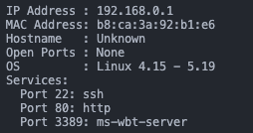

Performance and Runtime Metrics
Upon completion of each scan, the scanner reported total runtime statistics. For subnet scans, the use of concurrent port scanning significantly reduced overall execution time compared to sequential scanning. The recorded runtime metrics demonstrate that the scanner operates efficiently within the constraints of the laboratory network.

Bonus:
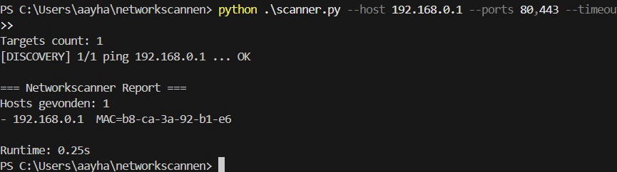

Output Consistency and Export
Across multiple executions, the scanner produced consistent and reproducible results. The structured terminal output improved readability and made it easier to compare hosts. When enabled, exporting scan results to a structured file format allowed scan data to be preserved for further analysis or documentation.

Discussion

This section reflects on the design, implementation, and results of the network scanner. The discussion evaluates how well the scanner meets the assignment requirements, analyzes design decisions and trade-offs, and compares the initial design with the final implementation.

Evaluation of Requirements
The implemented network scanner meets all functional requirements defined in the assignment. The scanner is capable of scanning both single hosts and entire subnets, identifying IP and MAC addresses, detecting open TCP ports, mapping services to open ports, resolving hostnames, and presenting results in a structured and readable format. Where permitted, external tools were used in a controlled manner, ensuring compliance with the assignment constraints.

Design and Implementation Trade-offs
Several design trade-offs were encountered during development. ICMP-based host discovery was selected for its simplicity and cross-platform compatibility, although it may fail in environments where ICMP traffic is filtered. This limitation was considered acceptable within the controlled laboratory environment.
Similarly, TCP connect scanning was chosen over more advanced scanning techniques to ensure reliability and portability. While this approach is less stealthy and potentially slower than low-level packet-based scans, it provides consistent results and avoids operating system-specific dependencies.

Iterative Development and Enhancements
The scanner was developed iteratively, starting with a basic implementation that satisfied the core requirements. Based on testing and evaluation, additional features were introduced to improve usability and performance. These enhancements included extensive command-line configurability, real-time progress reporting, concurrent port scanning, runtime metrics, and optional banner grabbing.
This iterative approach allowed functionality to be validated incrementally while maintaining a clear correspondence between the original pseudocode and the final implementation.

Differences Between Pseudocode and Final Implementation
While the final implementation closely follows the original pseudocode, some differences emerged during development. Concurrency was introduced in the port scanning phase to improve performance, which was not explicitly defined in the initial pseudocode. Additionally, optional features such as banner grabbing and result export were added after the core functionality had been implemented.
These differences reflect practical considerations that arose during testing and demonstrate adaptive problem-solving rather than deviations from the original design intent.

Limitations
Despite meeting the assignment objectives, the scanner has several limitations. Host discovery relies on ICMP echo requests and may not detect hosts that block such traffic. UDP-based services are not scanned, and operating system detection is limited to optional external tooling. Additionally, the scanner does not attempt to evade detection or minimize scan footprint, as stealth was not a design objective for this assignment.

Learning Outcomes
Developing the network scanner provided practical insight into network discovery and scanning techniques. The project reinforced the importance of understanding underlying network mechanisms rather than relying exclusively on existing tools. It also highlighted the value of modular design, iterative development, and clear documentation when building security-related software.

Conclusion

This project demonstrated the design, implementation, and evaluation of a custom-built network scanner developed for network mapping purposes. The scanner successfully met all functional requirements by supporting both single-host and subnet scans, identifying active systems, detecting open ports, mapping services, and presenting results in a structured and readable format.

Through an iterative development process, the scanner was extended with advanced features such as extensive command-line configurability, concurrent port scanning, progress reporting, runtime metrics, and optional banner grabbing. These enhancements improved both usability and performance while maintaining clarity and compliance with the assignment constraints.

The project reinforced the importance of understanding fundamental network scanning techniques and translating theoretical concepts into practical implementations. The resulting scanner provides a solid foundation for future extensions and serves as a valuable learning exercise in security tool development.

References

[1] Python Software Foundation. (2024). Python 3 Documentation.
Retrieved from https://docs.python.org/3/

[2] Scapy Development Team. (2024). Scapy: Interactive Packet Manipulation.
Retrieved from https://scapy.net/

[3] Lyon, G. F. (2024). Nmap Reference Guide.
Retrieved from https://nmap.org/book/

[4] Python Software Foundation. (2024). argparse — Parser for Command-Line Options.
Retrieved from https://docs.python.org/3/library/argparse.html

[5] Python Software Foundation. (2024). socket — Low-level Networking Interface.
Retrieved from https://docs.python.org/3/library/socket.html

[6] Python Software Foundation. (2024). concurrent.futures — Launching Parallel Tasks.
Retrieved from https://docs.python.org/3/library/concurrent.futures.html

[7] Github project code.
https://github.com/n-nawras/Security-Engineering-in-de-praktijk-Groep-1

[8] Code:
#!/usr/bin/env python3
"""
Network Scanner
Scans a single host or a subnet to discover IP, MAC, open ports,
services and operating system.

Author: Student
"""

import argparse
import socket
from scapy.all import ARP, Ether, srp
import nmap

def parse_arguments():
"""
Parse command-line arguments.
"""
parser = argparse.ArgumentParser(description="Simple Network Scanner")
parser.add_argument(
"-t",
"--target",
required=True,
help="Target IP or subnet (e.g. 192.168.0.10 or 192.168.0.0/24)"
)
return parser.parse_args()

def arp_scan(target):
"""
Perform an ARP scan to discover live hosts.

:param target: IP address or subnet
:return: list of dictionaries with ip and mac
"""
arp_request = ARP(pdst=target)
broadcast = Ether(dst="ff:ff:ff:ff:ff:ff")
packet = broadcast / arp_request

answered = srp(packet, timeout=2, verbose=False)[0]

hosts = []
for sent, received in answered:
hosts.append({
"ip": received.psrc,
"mac": received.hwsrc
})

return hosts

def scan_ports(ip, ports):
"""
Scan TCP ports on a host.

:param ip: IP address
:param ports: list of ports
:return: list of open ports
"""
open_ports = []

for port in ports:
try:
sock = socket.socket(socket.AF_INET, socket.SOCK_STREAM)
sock.settimeout(0.5)
result = sock.connect_ex((ip, port))
sock.close()

if result == 0:
open_ports.append(port)
except socket.error:
pass

return open_ports

def nmap_scan(ip):
"""
Use nmap to detect OS and services.

:param ip: IP address
:return: tuple (os, services)
"""
nm = nmap.PortScanner()
nm.scan(ip, arguments="-O -sV")

os_name = "Unknown"
services = {}

if "osmatch" in nm[ip] and nm[ip]["osmatch"]:
os_name = nm[ip]["osmatch"][0]["name"]

if "tcp" in nm[ip]:
for port in nm[ip]["tcp"]:
service = nm[ip]["tcp"][port]["name"]
services[port] = service

return os_name, services

def resolve_hostname(ip):
"""
Resolve hostname for an IP address.

:param ip: IP address
:return: hostname or 'Unknown'
"""
try:
return socket.gethostbyaddr(ip)[0]
except socket.herror:
return "Unknown"

def main():
"""
Main function.
"""
args = parse_arguments()
target = args.target

print(f"\nScanning target: {target}\n")

hosts = arp_scan(target)

if not hosts:
print("No hosts found.")
return

ports_to_scan = [21, 22, 23, 25, 53, 80, 110, 139, 143, 443, 445, 3389]

for host in hosts:
ip = host["ip"]
mac = host["mac"]
hostname = resolve_hostname(ip)

print("-" * 50)
print(f"IP Address : {ip}")
print(f"MAC Address: {mac}")
print(f"Hostname : {hostname}")

open_ports = scan_ports(ip, ports_to_scan)
print(f"Open Ports : {open_ports if open_ports else 'None'}")

os_name, services = nmap_scan(ip)
print(f"OS : {os_name}")

if services:
print("Services:")
for port, service in services.items():
print(f" Port {port}: {service}")
else:
print("Services : None")

print("\nScan completed.\n")

if __name__ == "__main__":
main()

[8] bonus Code:
import argparse
import ipaddress
import json
import platform
import re
import socket
import ssl
import subprocess
import time
from concurrent.futures import ThreadPoolExecutor

# -----------------------------
# CLI
# -----------------------------
def parse_args():
p = argparse.ArgumentParser(description="Networkscanner (lab opdracht)")
g = p.add_mutually_exclusive_group(required=True)
g.add_argument("--host", help="Scan 1 host, bv 192.168.0.1")
g.add_argument("--subnet", help="Scan subnet (CIDR), bv 192.168.0.0/24")

p.add_argument("--limit", type=int, default=49, help="Max hosts (lab: 49)")
p.add_argument("--ports", default="", help="Ports: 22,80,443 of 1-1024")
p.add_argument("--top-ports", type=int, default=0, help="Scan top N ports (bv 100). 0=uit")
p.add_argument("--timeout", type=float, default=0.5, help="Timeout (sec) voor ping + TCP connect")

p.add_argument("--workers", type=int, default=200, help="Threads voor port scan")
p.add_argument("--banner", action="store_true", help="Probeert banner te lezen op open ports")
p.add_argument("--output", default="", help="Schrijf resultaat naar bestand (json)")
p.add_argument("--no-color", action="store_true", help="Disable kleuren in output (optioneel)")

return p.parse_args()

# -----------------------------
# Targets + discovery
# -----------------------------
def build_targets(args) -> list[str]:
if args.host:
return [args.host]

net = ipaddress.ip_network(args.subnet, strict=False)
targets: list[str] = []
for ip in net.hosts():
targets.append(str(ip))
if len(targets) >= args.limit:
break
return targets

def ping_once(ip: str, timeout: float) -> bool:
system = platform.system().lower()
if system.startswith("win"):
cmd = ["ping", "-n", "1", "-w", str(int(timeout * 1000)), ip]
else:
cmd = ["ping", "-c", "1", "-W", str(max(1, int(timeout))), ip]

r = subprocess.run(cmd, stdout=subprocess.DEVNULL, stderr=subprocess.DEVNULL)
return r.returncode == 0

def discover_alive(targets: list[str], timeout: float) -> list[str]:
alive: list[str] = []
for i, ip in enumerate(targets, start=1):
ok = ping_once(ip, timeout)
print(f"[DISCOVERY] {i}/{len(targets)} ping {ip} ... {'OK' if ok else 'no reply'}")
if ok:
alive.append(ip)
return alive

# -----------------------------
# Ports
# -----------------------------
COMMON_TOP_PORTS = [
21, 22, 23, 25, 53, 80, 110, 111, 135, 139, 143, 443, 445, 993, 995,
1723, 3306, 3389, 5900, 8080
]

def parse_ports(s: str) -> list[int]:
s = (s or "").strip()
if not s:
return []

def _as_int(x: str) -> int:
x = x.strip()
if not x.isdigit():
raise ValueError(f"ongeldig port '{x}' (geen getal)")
v = int(x)
if not (1 <= v <= 65535):
raise ValueError(f"ongeldig port '{x}' (buiten 1-65535)")
return v

if "-" in s:
a, b = s.split("-", 1)
start = _as_int(a)
end = _as_int(b)
if start > end:
start, end = end, start
return list(range(start, end + 1))

out: list[int] = []
for p in s.split(","):
p = p.strip()
if not p:
continue
out.append(_as_int(p))
return out

def select_ports(args) -> list[int]:
# 1) expliciet --ports wint altijd
ports = parse_ports(args.ports)
if ports:
return ports

# 2) anders: top-ports = exact N
if args.top_ports and args.top_ports > 0:
n = args.top_ports
if n <= len(COMMON_TOP_PORTS):
return COMMON_TOP_PORTS[:n]
# als N groter dan de lijst: simpel 1..N
return list(range(1, n + 1))

# 3) default (klein)
return [22, 80, 443, 445, 3389]

def service_name(port: int) -> str:
try:
return socket.getservbyport(port, "tcp")
except OSError:
return "unknown"

def scan_ports(ip: str, ports: list[int], timeout: float, workers: int) -> list[int]:
def check(port: int) -> int | None:
try:
with socket.socket(socket.AF_INET, socket.SOCK_STREAM) as sock:
sock.settimeout(timeout)
return port if sock.connect_ex((ip, port)) == 0 else None
except Exception:
return None

if not ports:
return []

max_workers = max(1, min(workers, len(ports)))
open_ports: list[int] = []
with ThreadPoolExecutor(max_workers=max_workers) as ex:
for res in ex.map(check, ports):
if res is not None:
open_ports.append(res)
return sorted(open_ports)

# -----------------------------
# MAC
# -----------------------------
def get_mac(ip: str) -> str | None:
system = platform.system().lower()
try:
if system.startswith("win"):
out = subprocess.check_output(["arp", "-a", ip], text=True, errors="ignore")
m = re.search(rf"^\s*{re.escape(ip)}\s+([0-9a-fA-F-]{{17}})\s", out, re.MULTILINE)
return m.group(1).lower() if m else None
else:
out = subprocess.check_output(["ip", "neigh", "show", ip], text=True, errors="ignore")
m = re.search(r"lladdr\s+([0-9a-fA-F:]{17})", out)
return m.group(1).lower() if m else None
except Exception:
return None

# -----------------------------
# Banner (optioneel)
# -----------------------------
def _clean_banner(text: str, limit: int = 90) -> str:
text = "".join(ch for ch in text if ch.isprintable())
text = " ".join(text.split())
return text[:limit]

def _http_banner(ip: str, port: int, timeout: float, tls: bool) -> str | None:
req = (
f"HEAD / HTTP/1.1\r\n"
f"Host: {ip}\r\n"
f"User-Agent: netscanner\r\n"
f"Connection: close\r\n\r\n"
).encode()

try:
raw = b""
if tls:
ctx = ssl.create_default_context()
ctx.check_hostname = False
ctx.verify_mode = ssl.CERT_NONE
with socket.create_connection((ip, port), timeout=timeout) as sock:
sock.settimeout(timeout)
with ctx.wrap_socket(sock, server_hostname=None) as ssock:
ssock.sendall(req)
raw = ssock.recv(2048)
else:
with socket.create_connection((ip, port), timeout=timeout) as sock:
sock.settimeout(timeout)
sock.sendall(req)
raw = sock.recv(2048)

text = raw.decode(errors="ignore")
m = re.search(r"^Server:\s*(.+)$", text, re.MULTILINE | re.IGNORECASE)
if m:
return _clean_banner(m.group(1))
first = text.splitlines()[0] if text else ""
return _clean_banner(first) if first else None
except Exception:
return None

def grab_banner(ip: str, port: int, timeout: float) -> str | None:
try:
if port in (80, 8080, 8000):
return _http_banner(ip, port, timeout, tls=False)
if port == 443:
return _http_banner(ip, port, timeout, tls=True)

with socket.create_connection((ip, port), timeout=timeout) as s:
s.settimeout(timeout)
try:
data = s.recv(256)
except Exception:
data = b""

if not data:
try:
s.sendall(b"\r\n")
except Exception:
pass
try:
data = s.recv(256)
except Exception:
data = b""

if not data:
return None
return _clean_banner(data.decode(errors="ignore"))
except Exception:
return None

# -----------------------------
# Main
# -----------------------------
def main() -> int:
args = parse_args()
start = time.perf_counter()

try:
targets = build_targets(args)
except ValueError as e:
print(f"[ERROR] Ongeldig subnet: {e}")
return 2

print(f"Targets count: {len(targets)}")

alive = discover_alive(targets, args.timeout)

try:
ports = select_ports(args)
except ValueError as e:
print(f"[ERROR] Ongeldige --ports: {e}")
return 2

for ip in alive:
mac = get_mac(ip) or "unknown"
open_ports = scan_ports(ip, ports, args.timeout, args.workers)

banners: dict[str, str] = {}
details: list[str] = []
for p in open_ports:
svc = service_name(p)
if args.banner:
b = grab_banner(ip, p, args.timeout)
if b:
banners[str(p)] = b
details.append(f"{p}({svc}) banner='{b}'")
else:
details.append(f"{p}({svc})")
else:
details.append(f"{p}({svc})")

pretty = ", ".join(details) if details else "-"
print(f"- {ip:<15} MAC={mac:<17} open TCP: {pretty}")

host_item = {"ip": ip, "mac": mac, "open_tcp": open_ports}
if args.banner and banners:
host_item["banners"] = banners
results["hosts"].append(host_item)

runtime = time.perf_counter() - start
results["runtime_sec"] = round(runtime, 2)
print(f"\nRuntime: {runtime:.2f}s")

if args.output:
with open(args.output, "w", encoding="utf-8") as f:
json.dump(results, f, indent=2)
print(f"[OK] Saved to {args.output}")

return 0

if __name__ == "__main__":
raise SystemExit(main())

